3GPP TSG RAN WG1 Meeting #125 R1-2604762
Dalian, China, May. 18th – 22nd, 2026
_____________________________________________________________________Agenda item: 10.8.3
Source: LG Electronics
Title: Discussion on waveform and frame structure for 6G ISAC
Document for: Discussion and decision
- Introduction
In RAN1 #124-bis, RAN1 made following agreements in AI 10.8.3 [1].
Agreement:
CP-OFDM waveform as defined for 6GR is the starting point for 6G ISAC waveform study.
Study on enhancements on CP-OFDM or other waveforms is not precluded.

Agreement:
6GR communication frame structure is the starting point for 6G ISAC frame structure study, in at least the following aspects.
- Frame/sub-frame/slot/symbol structure
- CP length
- SCS
Enhancements on frame structure/above aspects are not precluded.

Agreement:
Companies are encouraged to provide views on necessity/pros/cons/metrics of LLS and/or SLS and pros/cons/metrics of theoretical waveform characteristics analysis, for evaluation of ISAC waveform and/or integration with communication, to RAN1#125 meeting.

Agreement:
CP-OFDM is used as the benchmark for evaluating the benefits of sensing waveforms.
In this contribution, we discuss the issues related to the waveform and frame structure in 6G ISAC systems.
- Discussions
  - Waveform
    - CP-OFDM based reference signal design
It was agreed that CP-OFDM is taken as the starting point for ISAC reference signal design. In addition, under the discussion in AI 10.8.2, it was agreed that the study considers reference signal design based on the NR time-frequency resource grid, while taking into account the reuse or enhancement of existing NR reference signal structures as a baseline.
Agreement:
- On RS for ISAC, study at least the following aspects, considering sensing performance, resource overhead and impact to communication
  - RS for communication is reused for sensing
  - Enhanced RS for sensing, taking reuse of RS for communication as starting point
    - Note: Part of or all of the RS may be used for communication purpose, and it does not mean the final decision on whether the enhanced RS is used for communication purpose is to be made in this agenda.
  - Dedicated RS for sensing

Agreement:
- Study RE patterns of RS for sensing, considering sensing performance, resource overhead and impact to communication
- Note: enhancements on RS sequence if any will be discussed in agenda 10.8.3
For CP-OFDM based sensing, the reference signal RE pattern in the frequency domain is directly related to the sensing performance in the range domain. In particular, when the reference signal is mapped with a comb-type pattern having a uniform spacing in the frequency domain, the sampled frequency response has a periodic structure. As a result, after processing the sampled frequency-domain response for range estimation, the corresponding range-domain response may exhibit repeated peaks. These repeated peaks may make it difficult to distinguish the true target range from ambiguous range candidates, especially when the target distance is beyond the maximum unambiguous range associated with the frequency-domain sampling interval.
The maximum unambiguous range depends on the effective spacing between the reference signal REs in the frequency domain. With a uniformly spaced comb-type pattern, the periodicity of the RE positions may lead to a periodic ambiguity structure in the range domain. Although such a comb-type pattern is attractive from the perspective of overhead reduction and multiplexing with communication signals, the resulting ambiguity behavior needs to be carefully considered for ISAC target detection. This issue is particularly relevant when the sensing operation is expected to support a wide range of target distances while maintaining limited reference signal overhead.
One possible direction to mitigate the range ambiguity is to consider non-uniform RE patterns in the frequency domain. By avoiding a strictly periodic RE placement, the periodic ambiguity structure in the range-domain response can be reduced. In other words, a non-uniform RE pattern can provide additional degrees of freedom to shape the ambiguity characteristics while maintaining compatibility with the CP-OFDM based resource grid. Such a design direction can be considered without changing the basic CP-OFDM waveform assumption, and therefore it is suitable for further study under the current ISAC reference signal design framework.
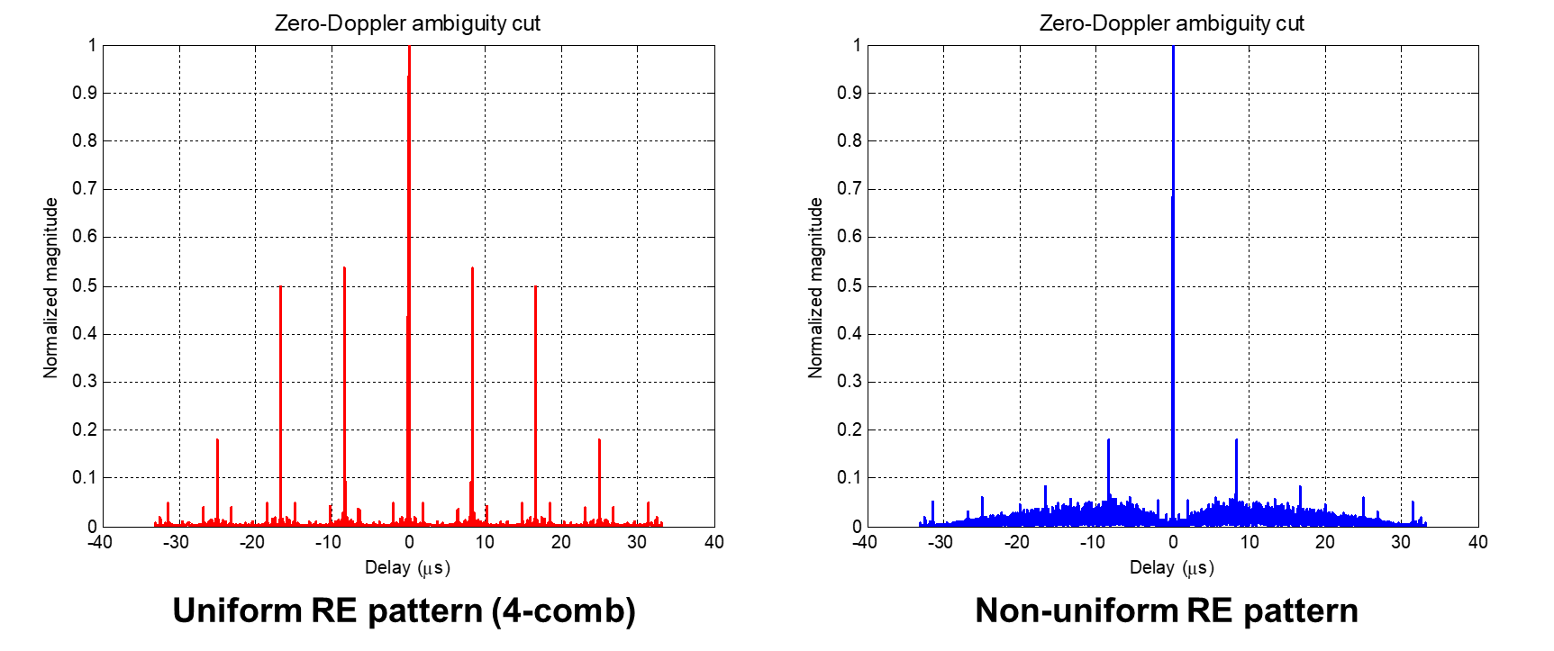
Figure 1. The zero-Doppler ambiguity functions of reference signals with different RE patterns
While a non-uniform RE pattern in the frequency domain can be beneficial for mitigating range ambiguity, its impact on the time-domain transmit waveform can also be considered. For CP-OFDM based transmission, the time-domain signal is generated by the superposition of the modulated subcarriers. Therefore, the RE positions and the sequence mapped to those REs jointly affect the envelope fluctuation of the transmitted signal. Compared with a uniformly spaced comb-type RE pattern, a non-uniform RE pattern may reduce the regularity of the frequency-domain mapping, but it may also lead to less controlled phase addition in the time domain. This increases the PAPR of the CP-OFDM based reference signal transmission.
Table 1. Simulation parameters for Ambiguity functions and PAPR
Parameters | Assumption
Waveform | CP-OFDM
FFT size | 4096
Subcarrier spacing | 30 kHz
Bandwidth | 100 MHz
Sequence | Zadoff-Chu sequence ($u=23, v=0$)
Resource overhead | 25%

Table 2. PAPR comparison of different RE patterns
RE pattern | PAPR
Uniform RE pattern (4-comb) | 5.64 dB
Non-uniform RE pattern | 8.36 dB

PAPR is an important aspect for reference signal design, since a higher PAPR may require a larger power amplifier back-off and may reduce the available transmit power for sensing reference signal transmission. This can be undesirable for ISAC operation, where the reference signal is expected to support reliable target detection while coexisting with communication channels and signals. Therefore, when non-uniform RE pattern is considered for mitigating range ambiguity, it is also necessary to study sequence designs that can maintain favorable transmit waveform properties.
There is precedent in NR for considering reference signal sequence designs with favorable PAPR and correlation properties. For example, SRS sequence design relies on low-PAPR base sequences and cyclic shifts, and PRACH preambles are generated based on cyclic shifts of root Zadoff-Chu sequences. These precedents indicate that sequence design and PAPR control have been considered as coupled aspects in NR reference signal design. In addition, recent RAN1 discussions on 6GR waveform characterization include proposals related to PAPR reduction and ISAC reference signals [3-5]. These discussions indicate that PAPR and reference signal design are closely related aspects and could be jointly considered when defining an ISAC reference signal.
For this purpose, low-PAPR sequence enhancements for non-uniform RE patterns can be studied. The study may include sequence structures that provide favorable envelope properties when mapped onto non-uniform frequency-domain RE positions, while maintaining good correlation properties for sensing. In particular, sequence structures with deterministic phase progression may be relevant candidates, since such structures can help control the phase relationship among the mapped REs and hence the time-domain envelope of the CP-OFDM signal. Some sequence families with structured phase progression may also be relevant from a sensing perspective, as they can provide favorable correlation properties. This aspect can be further related to the discussion on FMCW-based sensing in the next section, where chirp-based signal structures are considered from a waveform perspective.
Observation 1. Non-uniform RE patterns in the frequency domain may increase the PAPR of CP-OFDM based reference signal transmission.
Proposal 1. RAN1 studies low-PAPR sequence enhancements for non-uniform RS RE patterns in the frequency domain.

    - FMCW for sensing
Frequency modulated continuous wave (FMCW) is a conventional waveform that has been widely used in radar systems. The main principle of FMCW-based sensing is to transmit a chirp signal whose instantaneous frequency changes over time, and to estimate target parameters based on the frequency difference between the transmitted and received signals. In addition, FMCW signals based on chirp-like frequency sweeping are generally favorable from a transmit waveform perspective, since they can provide more controlled envelope characteristics and hence lower PAPR than multi-carrier OFDM signals. Therefore, FMCW-based sensing can be considered as a relevant reference waveform for studying sensing performance and implementation-related aspects in ISAC.
FMCW radar transmits a continuous signal whose instantaneous frequency is linearly swept over a certain bandwidth. The range information is extracted from the beat frequency between the transmitted and received signals, while Doppler information can be obtained by observing phase evolution across consecutive chirps. Due to this signal structure, FMCW radar has been extensively used and validated in real world radar deployments, particularly in scenarios requiring reliable short-to-medium range sensing with moderate computational complexity.
From a performance perspective, FMCW radar is well known to achieve fine range resolution determined by the sweep bandwidth and accurate Doppler estimation determined by the coherent processing interval. These properties have made FMCW a baseline waveform in the radar domain, providing a useful benchmark for evaluating alternative sensing waveforms, including communication-centric ones.
Observation 2. FMCW is a conventional waveform widely used in the radar field, with favorable transmit waveform characteristics including low-PAPR properties.
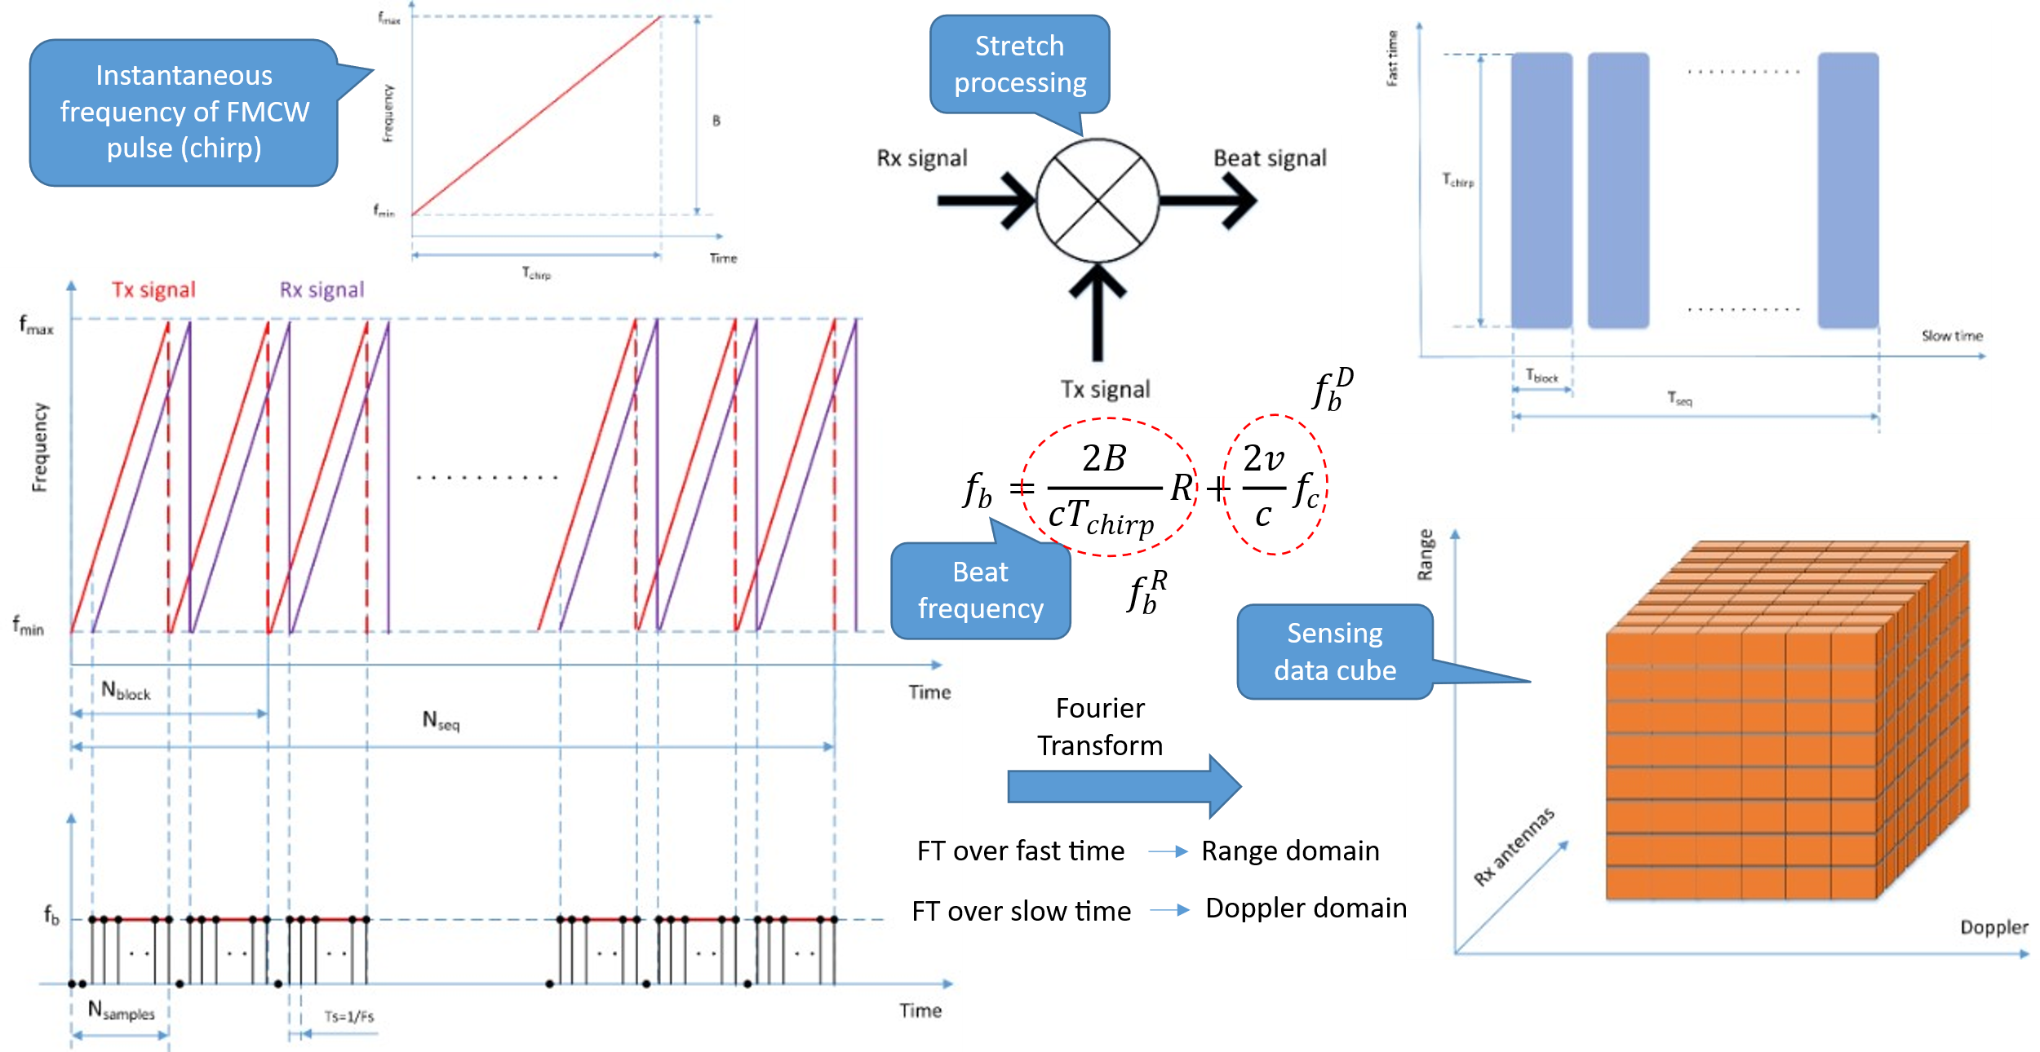
Figure 2. Structure of FMCW waveform and main steps of its processing
As a representative radar‑centric waveform, FMCW‑based sensing follows a processing structure that is fundamentally different from OFDM in the time domain, while yielding comparable sensing outputs in the range–Doppler domain. The FMCW‑based sensing processing chain is illustrated in Figure 2, which shows the main processing steps from chirp transmission to range–Doppler representation. In FMCW sensing, the instantaneous frequency of each transmitted chirp is linearly swept over a given bandwidth, and the received echo is processed using stretch (homodyne) processing to generate a beat signal. Range and Doppler information are then extracted by applying Fourier transforms over the fast‑time (within‑chirp samples) and slow‑time (across chirps) dimensions, respectively, resulting in a sensing data cube similar in structure to that obtained with OFDM‑based sensing.
Table 3. Simulation parameters for FMCW-based waveform
$F_{c}$  [GHz] | $$F_{s}$$[MHz] | $$B$$[MHz] | $$T_{chirp}$$[μs] | $$N_{sample}$$ | $$N_{seq}$$ | $$P_{TX}$$[dBM] | $$G_{TX}$$[dBi] | $$G_{RX}$$[dBi] | $$N_{F}$$[dB] | $$σ$$[dBsm] | Losses  [dB]
6 | 114.83 | 98.28 | 35.67 | 3979 | 256 | 20 | 3 | 3 | 6 | -10 | 2

The key simulation parameters for FMCW‑based sensing are summarized in Table 2. In order to enable a fair comparison with OFDM‑based sensing, the FMCW configuration is intentionally aligned with the OFDM experiment in terms of occupied bandwidth and signal duration. Specifically, the chirp bandwidth ($B$) is set to 98.28 MHz, and the chirp duration ($T_{chirp}$) is chosen to be equal to the OFDM symbol duration (including CP) used in the OFDM‑based sensing evaluation. Furthermore, all chirps are allocated to a single sensing link, and the number of chirps matches the number of OFDM symbols used in the corresponding OFDM experiment. This parameter alignment ensures that any observed performance differences are primarily attributable to waveform characteristics rather than resource imbalance. The transmit power ($P_{TX}$), antenna gains ($G_{TX}, G_{RX}$), noise factor ($N_{F}$), target radar cross section (RCS, $σ$), as well as implementation losses are also summarized in Table 2. These parameters are identical to those used in the OFDM‑based sensing experiment, enabling a direct comparison between FMCW‑ and OFDM‑based sensing under consistent assumptions.
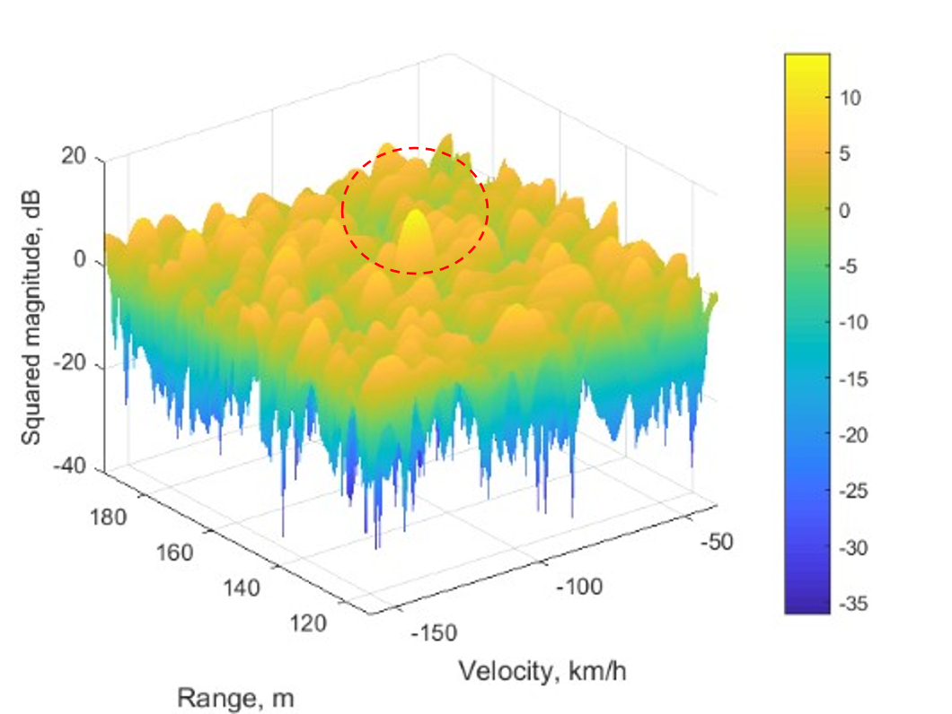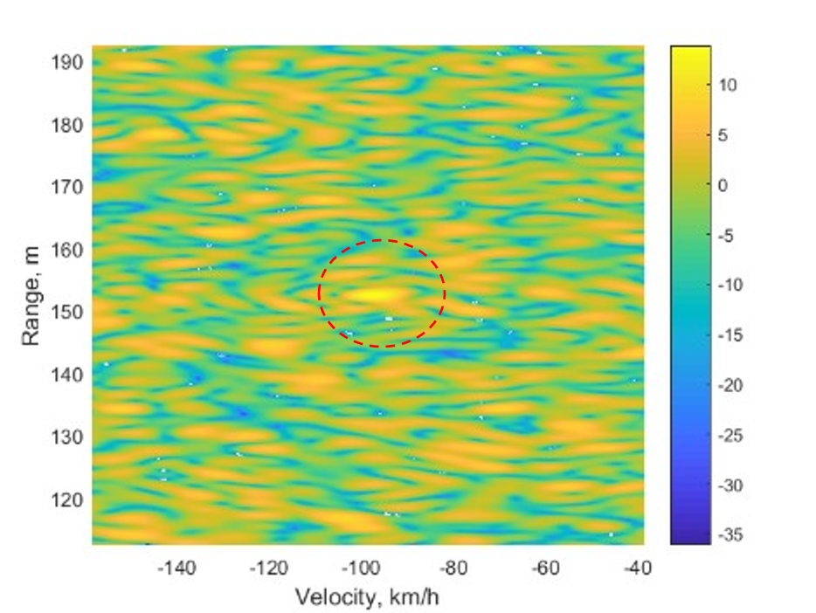
Figure 3. The range-Doppler response for a point target with FMCW-based waveform.
The resulting sensing response is illustrated in Figure 3, which shows both the range‑domain and velocity‑domain representations obtained using FMCW‑based sensing. As shown in the left plot, a distinct peak is observed at the location corresponding to the true target range, while the right plot exhibits a clear peak aligned with the true target radial velocity. The observed range–Doppler response confirms that FMCW‑based sensing can reliably recover both range and velocity of a point target under the considered configuration, using standard FMCW processing without additional waveform adaptations.
Notably, when the FMCW‑based results are compared with the corresponding OFDM‑based sensing results obtained under aligned bandwidth and signal duration, the overall sensing behavior is observed to be very similar. In both cases, the range–Doppler responses exhibit well‑defined peaks at the true target parameters, and no fundamental difference is observed in terms of achievable range or velocity estimation behavior for the point‑target scenario considered.
Observation 3. The sensing performance such as range accuracy, Doppler accuracy, and ambiguity behavior is observed to be very similar between OFDM‑based and FMCW‑based sensing when comparable bandwidth and signal duration are used.
In addition to point‑target evaluations, OFDM‑based sensing can be particularly challenged in interference‑limited environments. A comparative automotive radar study under interference conditions evaluated FMCW and OFDM radars configured with comparable parameters, including carrier frequency, bandwidth, transmitted power, and coherent integration time showed that while both waveforms can achieve similar sensing performance in interference‑free conditions with appropriate windowing, OFDM‑based sensing could be more sensitive to interference [6]. In particular, when an OFDM interferer overlaps with the signal of interest over the full channel bandwidth and symbol duration, the resulting response pattern can make it difficult, or even impossible, to identify the compressed echo corresponding to the target of interest without explicit interference cancellation. Although target detectability can be restored when the spectral overlap is limited, these results indicate a strong dependence of OFDM‑based sensing performance on interference conditions.
For FMCW‑based sensing in the same interference scenarios, the impact of interference is shown to depend on the coherence and duration of the interfering signal. Interference may appear as ghost‑like responses or as an elevated noise floor. However, depending on the scenario, target‑related responses can remain observable, illustrating relatively higher robustness of FMCW‑based sensing compared to OFDM‑based sensing in practical automotive‑type environments. These observations suggest that, although OFDM remains attractive as a baseline waveform for ISAC due to its tight integration with communication, there exist practically relevant scenarios—particularly those dominated by strong co‑channel interference—under which OFDM‑based sensing performance may be significantly degraded. In such scenarios, FMCW can serve as a complementary sensing waveform, motivating further study of FMCW within RAN1 to understand its achievable sensing performance and trade‑offs under interference‑limited conditions.
Observation 4. OFDM‑based sensing performance may be degraded under strong co‑channel interference.
Observation 5. FMCW‑based sensing performance can be less sensitive to the conditions under which OFDM‑based sensing performance is degraded, providing more robust sensing behavior in interference‑limited environments.
Proposal 2. FMCW can be studied as a candidate waveform in the ISAC study.
In addition to the interference robustness aspect, if FMCW-based sensing is further considered, the characteristics of the chirp signal itself need to be studied. An FMCW chirp can be characterized by its sweep direction, sweep slope, bandwidth, and duration. A chirp whose instantaneous frequency increases over time can be referred to as an up-chirp, while a chirp whose instantaneous frequency decreases over time can be referred to as a down-chirp. These chirp variations may provide different sensing characteristics, especially for moving targets where the Doppler shift is non-negligible.
For a single chirp direction, the beat frequency after de-chirping may contain both range-induced and Doppler-induced frequency components. As a result, the estimated range may be coupled with the target velocity, which may lead to range-Doppler coupling, ambiguity, or estimation bias. One possible direction to mitigate this issue is to consider triangular chirp-like signal with different sweep directions. For example, up-chirp and down-chirp signals can provide complementary beat-frequency characteristics, which can be useful for mitigating the coupling between range-related and Doppler-related components. Therefore, chirp signal variations, including the use of different sweep directions, need to be studied if FMCW-based sensing is further considered in RAN1.
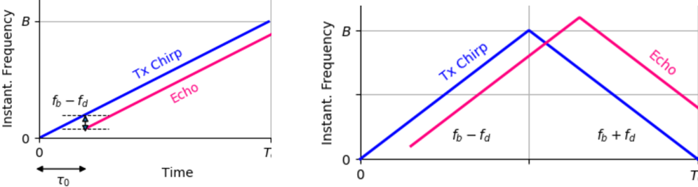
Figure 4. Mitigation of range-Doppler coupling using triangular chirp-like signals
The study of chirp signal variations also includes corresponding generation methods and implementation-related aspects. Such study may consider, for example, sweep direction, sweep slope, chirp duration, signal bandwidth, arrangement of multiple chirps, receiver processing assumptions, PAPR, power amplifier efficiency, waveform coexistence with communication signals, and sensing performance under relevant ISAC scenarios. For triangular chirp-like signal design, RAN1 may also need to study how up-chirp and down-chirp components are multiplexed within the sensing waveform. For example, the up-chirp and down-chirp components may be multiplexed in the time domain by allocating them to different symbols or time intervals, or in the frequency domain by allocating them to different frequency resources. Another possible structure is to interleave up-chirp and down-chirp components within a single symbol or sensing occasion as illustrated in Figure 5. In addition, triangular chirp-like signals can be generated by using frequency-domain sequences corresponding to truncated or masked frequency responses of intended time-domain chirp-like waveforms as illustrated in Figure 6. This may allow chirp-like sensing signals to be generated within an OFDM-compatible signal generation framework.
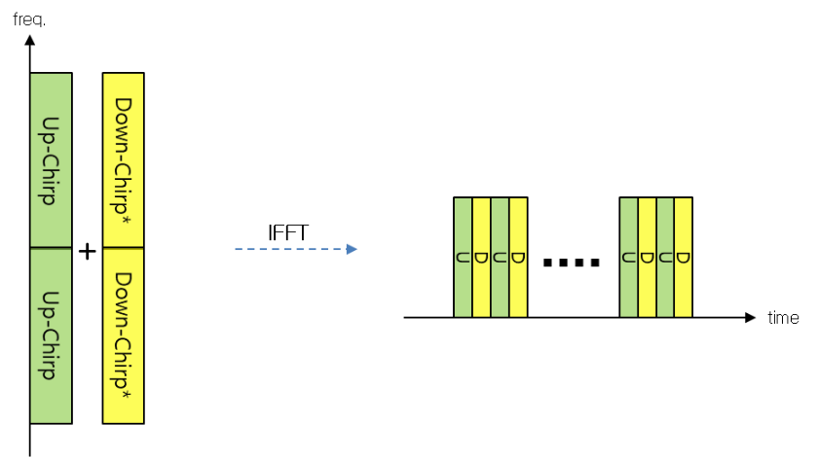
Figure 5. Interleaved up/down-Chirp in a single symbol
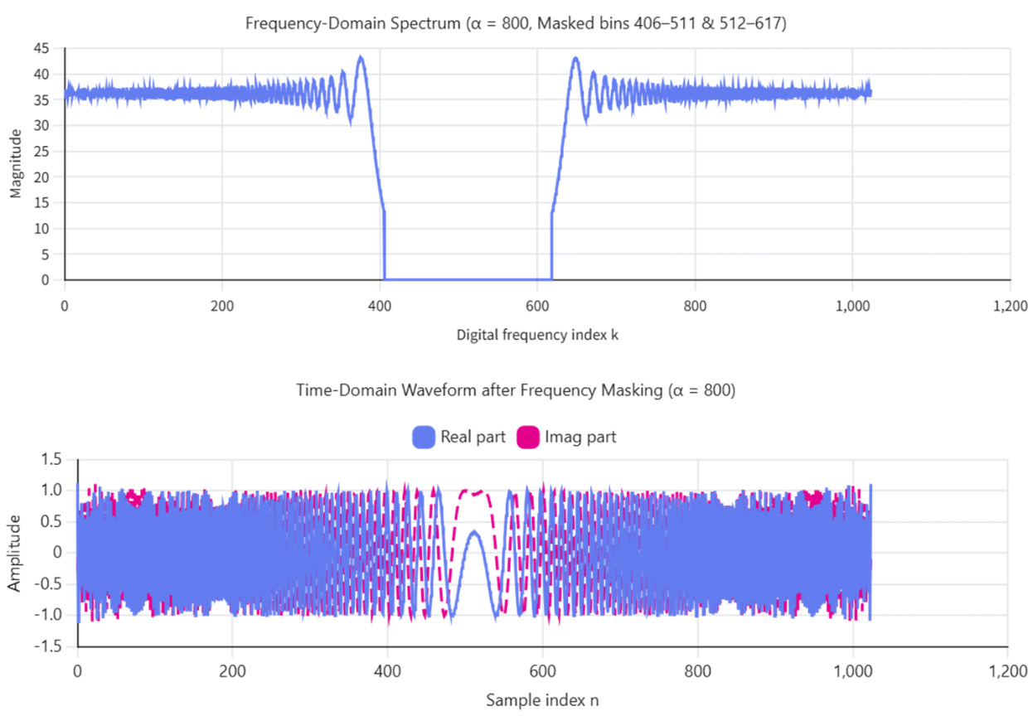
Figure 6. Truncated frequency response of chirp-like signal and time domain waveform
Observation 6. For FMCW-based sensing, chirp signals with different sweep directions, e.g., up-chirp and down-chirp, can be beneficial for mitigating range-Doppler coupling.
Proposal 3. If FMCW-based waveform is agreed to be further studied, RAN1 studies chirp signal variations and corresponding generation methods, taking into account sensing performance and implementation-related aspects.

    - Pulse waveform
Pulse waveform has been one of the most fundamental signal structures used in radar systems, particularly for applications requiring extended sensing coverage and flexible operation in both mono-static and bi-static sensing configurations. In the context of ISAC, pulse waveform characteristics provide several potential benefits that merit further study as part of the sensing waveform candidate set.
For both mono‑static sensing and bi‑static sensing, sensing coverage is strongly influenced by the transmitted power, duty cycle, and receiver integration capability. For long‑range sensing, transmission with sufficiently high power is generally required. However, in sensing configurations that rely on simultaneous transmission and reception, high‑power transmission may be constrained by self‑interference and dynamic range limitations at the receiver. In this regard, pulse‑based sensing enables explicit Tx/Rx switching in the time domain, allowing high‑power transmission during the transmit interval while avoiding simultaneous reception, thereby alleviating self‑interference issues. This characteristic makes pulse waveform operation well suited for high‑power sensing transmission under practical hardware constraints, and similar considerations have been discussed in the context of NR ISAC studies, where pulse‑oriented sensing was considered as a means to improve sensing coverage while managing Tx/Rx isolation challenges.
In bi‑static sensing scenarios, where the propagation paths and synchronization conditions between the transmitter and receiver can be less favorable, pulse waveform operation can further simplify echo separation and timing‑based processing. The time‑localized nature of pulse signals enables sensing echoes to be confined within well‑defined temporal windows, which facilitates clearer distinction among direct‑path, reflected‑path, and clutter components at the receiver. Such temporal separation can improve the robustness of sensing reception in complex deployments, particularly when multiple propagation paths and external interference sources are present. These characteristics are aligned with the ISAC study assumption that multiple sensing modes, including mono‑static and bi‑static configurations, need to be supported within a common framework, and indicate that pulse waveform operation can be beneficial for sensing coverage enhancement in both mono‑static and bi‑static sensing scenarios.
Observation 7. For sensing coverage enhancement in both mono-static sensing and bi-static sensing, pulse waveform can be beneficial.
While OFDM-based and FMCW based waveforms are naturally aligned with communication-centric designs, pulse waveform represents a complementary sensing-centric option. Studying pulse waveform within the ISAC framework allows RAN1 to better understand the performance envelope of sensing under extreme coverage or robustness-driven scenarios, and to identify whether pulse-based operation can provide meaningful gains compared to continuous or block-based waveforms.
Proposal 4. RAN1 studies a pulse waveform as a candidate waveform for sensing.
If a pulse waveform is agreed to be used for sensing, the pulse width becomes a key design parameter, as it directly affects sensing performance trade-offs such as range resolution, maximum unambiguous range, and receiver noise integration. From a radar perspective, a shorter pulse width generally improves range resolution but reduces the energy per pulse, whereas a longer pulse width improves detection sensitivity at the expense of resolution. In addition, different sensing scenarios, for example short-range high-resolution sensing versus long-range coverage-oriented sensing, may favor different pulse width configurations.
In addition to scenario-dependent pulse width selection, it may also be beneficial to support multiple pulse width values within a pulse train. A pulse train including different pulse widths can provide pulse-width diversity and enable a flexible trade-off between self-interference avoidance, range resolution, effective receive window, and detection sensitivity within the same sensing waveform. Accordingly, RAN1 may consider whether a single pulse width value is sufficient to simplify design and signaling or whether a set of pulse width values is needed to support diverse sensing requirements while maintaining manageable implementation
Observation 8. For pulse waveform-based sensing, supporting different pulse widths can provide flexibility of range resolution, and detection sensitivity.
Proposal 5. If a pulse waveform is agreed to be further studied for sensing, RAN1 studies supported pulse width configuration(s), including whether a single pulse width value or a set of pulse width values is needed.
If a pulse waveform is agreed to be used for sensing, the exact shape of the pulse waveform also needs to be studied, as it directly affects spectral characteristics, ambiguity behavior, and implementation complexity, as well as the ability to support multiplexing among multiple sensing entities. From a waveform design perspective, a simple rectangular pulse without modulation offers straightforward time‑domain processing and clear interpretation of echo timing, but may suffer from poor spectral containment and limited ambiguity shaping, and may provide limited flexibility for multiplexing when multiple sensing transmissions coexist. Introducing modulation, such as phase or amplitude modulation, within a rectangular pulse can improve ambiguity properties and spectral efficiency while preserving the basic pulse structure, and may also provide additional degrees of freedom for distinguishing and multiplexing sensing signals from different entities, an approach that has been widely adopted in radar systems to enhance detection and resolution performance. Alternatively, an existing waveform, such as an OFDM‑based or FMCW‑based signal, may be confined within a pulse duration, allowing reuse of well‑understood waveform properties while benefiting from pulse‑based operation and duty‑cycle control. Each of these pulse waveform options represents a different trade‑off among simplicity, sensing performance, multiplexing capability, and compatibility with communication‑centric designs, and therefore warrants further study within the ISAC framework.
Proposal 6. If pulse waveform is agreed to be used for sensing, RAN1 studies the exact shape of pulse waveform.
  - Rectangular pulse without modulation
  - Rectangular pulse with modulation
  - A waveform (e.g., OFDM/FMCW) of pulse width
If a pulse waveform is agreed to be used for sensing, additional studies are required to ensure practical integration into the ISAC framework. In particular, when a rectangular pulse with modulation is considered, RAN1 needs to study the exact modulation method, including candidate modulation types and their impact on sensing performance, spectral characteristics, and receiver complexity. Similarly, if an existing waveform confined within a pulse duration is adopted, such as an OFDM waveform based or FMCW-based pulse waveform, RAN1 needs to study the corresponding waveform generation method. For an OFDM waveform-based pulse generation approach, the study may need to consider how pulse-like time-domain characteristics can be obtained within an OFDM-compatible waveform and resource-grid framework. This may include, for example, time-domain pulse shaping or windowing, numerology-dependent waveform configuration, frequency-domain resource patterning, pulse duration and bandwidth configuration, and the required generation parameters to be indicated or configured.
Proposal 7. If rectangular pulse with modulation is agreed, RAN1 needs to study the exact modulation method.
Proposal 8. If pulse waveform is agreed to be used for sensing, RAN1 needs to study the generation method of pulse waveform.

    - Waveform specification for different sensing modes
In the previous RAN1 discussion, it was identified that the necessity and potential benefits of specifying a waveform for TRP monostatic sensing, TRP-TRP bistatic sensing, and UE monostatic sensing need to be further considered. It is necessary to clarify whether the waveform for some sensing modes can be left entirely to implementation or whether a standardized waveform framework is needed.
For TRP monostatic sensing and UE monostatic sensing, one possible view is that the waveform may be regarded as an implementation issue, since the sensing transmitter and sensing receiver are located at the same sensing entity. In such a case, the sensing entity transmits a sensing signal and processes the received echo by itself, and there may be no explicit waveform negotiation between different sensing entities. However, even for monostatic sensing, the transmitted sensing signal is radiated over the air within the 3GPP system and commercial mobile spectrum. Therefore, the waveform cannot be considered purely as an internal implementation matter. The sensing waveform may need to satisfy system-level constraints such as coexistence with communication signals, interference management, sensing signal multiplexing, and network-controlled operation.
In addition, monostatic sensing may not be isolated from other sensing modes. A waveform transmitted for TRP monostatic sensing may also be observed by other TRPs or UEs and may be reused for bistatic or multi-static sensing operation. Similarly, a waveform used for UE monostatic sensing may affect neighboring receivers or may need to be coordinated with network-controlled sensing resources and sensing measurements. If different implementations use proprietary monostatic sensing waveforms without a common framework, the network may need to handle multiple waveform assumptions, which may complicate interference handling, measurement interpretation, and coexistence with communication.
For TRP-TRP bistatic sensing, the need for waveform specification is more direct. In this sensing mode, the sensing transmitter and sensing receiver are different TRPs. In particular, if the transmitting TRP and the receiving TRP are from different vendors, the receiving TRP needs to have sufficient knowledge of the transmitted sensing waveform in order to perform sensing reception and processing. Without a common waveform specification or at least a common waveform framework, the receiving TRP may not be able to properly interpret the received signal, perform matched processing, distinguish the intended sensing signal from interference, or report consistent sensing measurements.
TRP-TRP bistatic sensing also involves inter-TRP operation within a common ISAC system. The waveform design may affect inter-TRP coordination, timing assumptions, sensing signal identification, interference management, and coexistence with communication operation. If the waveform is entirely left to implementation, multi-vendor TRP-TRP bistatic sensing may become difficult to support, and network-level sensing operation may be fragmented across different proprietary waveform choices. Therefore, RAN1 needs to study waveform specification for TRP-TRP bistatic sensing to enable common understanding between sensing Tx and sensing Rx TRPs and to support scalable ISAC operation.
Proposal 9. RAN1 studies the necessity and potential benefits of specifying waveforms for TRP monostatic sensing, TRP-TRP bistatic sensing, and UE monostatic sensing.

  - Frame structure
    - CP for ISAC
This section discusses the role of the cyclic prefix (CP) in the frame structure for 6G ISAC, with a focus on how sensing signals can be accommodated within an OFDM-based frame while avoiding unintended interference.
In communication-oriented OFDM systems, the CP length is typically designed to absorb the expected multipath delay spread of the communication channel. However, in ISAC, sensing signals may be scattered by objects located at relatively long distances. As a result, the propagation delay of sensing echoes can exceed the CP length configured for communication, which limits sensing coverage in terms of maximum tolerable range. As OFDM-based sensing relies on frequency domain channel estimates, This implies a fundamental requirement that the maximum delay in the target channel must not exceed the CP length ($T_{CP}$). This constraint defines the maximum tolerable range as a function of the CP length
$$R_{tol}=\frac{cT_{CP}}{2}$$ | (1)
One can conclude that a longer CP is preferable. Given $T_{CP}$ = 2.34 μs, equation (1) yields $R_{tol}$ = 351 m. It is evident that this range is insufficient for the majority of practical use cases. The constraint due to the maximum tolerable range manifests itself through inter‑symbol interference (ISI) when the maximum delay in the target channel exceeds the CP length. In such cases, the delayed sensing echoes extend beyond the CP duration and overlap with subsequent OFDM symbols, resulting in ISI that distorts the received sensing signal. Even when the excess delay is on the order of a few times the CP length, the resulting ISI can degrade the quality of channel estimates and range‑Doppler processing, leading to reduced sensing accuracy and increased ambiguity. Therefore, the maximum tolerable range imposed by the CP length represents a practical limitation for OFDM‑based sensing and motivates the need for explicit mechanisms to mitigate sensing‑induced ISI within the ISAC frame structure.
Observation 9. The sensing signal scattered by an object can propagate beyond OFDM CP length, which may cause inter-symbol interference between adjacent symbols.
From a frame structure perspective, ISI caused by sensing signals propagating beyond the CP length may not only degrade communication reception but also adversely affect sensing processing, particularly when sensing and communication symbols are closely packed in the time domain. In ISAC scenarios, sensing echoes may exhibit longer delay spreads than those typically assumed in communication‑oriented CP design, which motivates the need to consider dedicated mechanisms to mitigate sensing‑induced ISI within the OFDM‑based frame structure. One possible approach is to extend the CP length for sensing symbols so that longer delay components can be absorbed within the CP, although this directly modifies the OFDM symbol structure and may increase overhead.
Alternatively, introducing a silent gap (guard time) before and/or after sensing symbols can provide protection against long‑delay sensing echoes without modifying the CP itself, at the cost of reduced time‑domain efficiency and additional symbol alignment considerations. To address these considerations, a pulse‑type waveform can be applied for sensing, as its time‑localized structure naturally accommodates guard intervals and facilitates clearer separation between sensing transmissions and delayed echoes within the frame structure.
Another option is to repeat the same OFDM symbol, thereby providing an effective CP extension such that delayed sensing echoes overlap with identical symbols rather than causing additional interference, trading time resources for improved robustness. These approaches represent different trade‑offs among overhead, robustness, and implementation complexity, and therefore warrant further physical‑layer study within the ISAC frame structure context. In particular, an effective CP‑like behavior can also be achieved by transmitting the sensing reference signal with a frequency‑domain pattern where the sensing RS is allocated every $N$ subcarriers, which results in repetition of OFDM symbols whose effective time‑domain duration is shortened by a factor of $N$. In this case, the repeated $N$ symbols correspond to the same sensing content in the time domain, and either the first few symbols or the last few symbols among the repeated symbols can be omitted from transmission to create an effective silent interval. The value of $N$ can be selected based on the required duration of the silent gap needed to accommodate long‑delay sensing echoes. Such an approach provides a frequency‑domain realization of effective CP extension while leveraging the existing OFDM framework, and requires further RAN1 study to evaluate how it mitigates interference caused by sensing signal propagation beyond the CP length and how it impacts frame structure design and implementation complexity.
Proposal 10. RAN1 studies how to handle the interference from the sensing signal that propagates beyond the OFDM CP length.
  - Alt 1: CP length extension
  - Alt 2: Silent gap before and/or after a sensing signal
  - Alt 3: Effective CP extension by symbol repetition

    - SCS for ISAC
This section discusses SCS design for ISAC from a frame structure and numerology perspective, focusing on the coexistence of sensing and communication within a common OFDM framework.
In NR, SCS determines the OFDM symbol duration and directly impacts the frame and slot structure. Using the same SCS for sensing and communication allows sensing symbols to be naturally embedded within the communication frame structure. Aligning sensing and communication SCS enables reuse of the same FFT size, sampling rate, and timing reference, thereby simplifying transceiver implementation and frame-level scheduling. This baseline approach facilitates tight integration of sensing and communication within a unified frame structure. In addition, it is important to clarify the extent to which the SCS impacts sensing coverage in the velocity domain for OFDM-based sensing. In OFDM-based sensing, the orthogonality among subcarriers is disrupted by Doppler shift, which leads to inter-carrier interference (ICI). As a result, the maximum tolerable velocity can be defined based on the condition that the Doppler shift is sufficiently smaller than the SCS, so that ICI remains negligible.
Observation 10. In OFDM‑based sensing, the SCS affects sensing coverage in the velocity domain by determining the maximum tolerable target velocity under Doppler‑induced inter‑carrier interference.
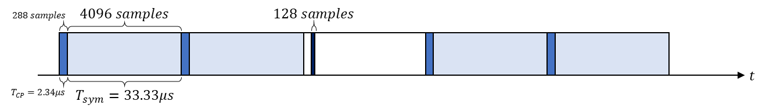
Figure 7. Example of pulse-type OFDM waveform with larger SCS
In addition to reusing the communication SCS, SCS can also be considered as a key design parameter for generating pulse‑like sensing waveforms within an OFDM framework. Increasing the SCS shortens the OFDM symbol duration, thereby enabling a time‑localized waveform that approximates a pulse suitable for sensing applications, while impacting symbol granularity and the arrangement of sensing symbols relative to communication symbols within the shared time–frequency grid. To illustrate this with a numerical example, consider a system bandwidth of 100 MHz and a fixed sampling rate of 122.88 MHz, where a conventional 30 kHz SCS results in an OFDM symbol duration of approximately 33.33 μs. If a pulse width on the order of 1 μs is targeted for sensing, the corresponding sensing‑oriented SCS needs to be increased to approximately 960 kHz, under which the OFDM symbol duration becomes comparable to the desired pulse width and the required IFFT size can be reduced to 128 while maintaining the same sampling rate. An example configuration illustrating the relationship between large SCS, reduced OFDM symbol duration, and effective pulse width is shown in Figure 7, demonstrating that a sensing‑specific large‑SCS numerology provides a practical means to realize pulse‑oriented sensing within an OFDM‑based ISAC framework, albeit potentially leading to a mixed‑numerology scenario that requires further consideration of alignment and coexistence with the communication numerology.
Observation 11. As one of the pulse waveform generation methods, a larger SCS can be used to shorten OFDM symbol duration.
Proposal 11. If a pulse waveform is agreed to be used for sensing, RAN1 studies whether to support a larger SCS for sensing.
Proposal 12. If a pulse waveform is agreed to be used for sensing, SCS for sensing can be determined according to the required pulse waveform width.

    - Enhancement on frame structure for ISAC
This section discusses frame structure enhancements for 6G ISAC from a RAN1 physical-layer perspective. In particular, the focus is on frame structure support for pulse-based sensing, when a pulse waveform is considered as a candidate sensing waveform.
A pulse waveform is characterized by a short-duration transmission interval followed by a reception interval for observing the reflected sensing signal. This time-domain behavior is different from a conventional OFDM symbol that occupies the full symbol duration for transmission. Therefore, if pulse-based sensing is supported within an OFDM-compatible framework, the relationship between the pulse transmission interval and the OFDM symbol boundary needs to be considered from a frame structure perspective.
For example, a pulse-like sensing transmission may be generated within a time duration associated with an OFDM symbol, while only a part of the symbol duration is effectively used for sensing transmission. Alternatively, a pulse-like sensing transmission may be realized by using a shorter sensing-oriented OFDM symbol duration compared with the baseline communication symbol duration. In both cases, the resulting time-domain structure includes a short sensing transmission interval and a subsequent quiet period that can be used for sensing reception or for avoiding interference to the reception of delayed echoes.
The quiet period is an important frame-structure-related aspect for pulse-based sensing. In monostatic sensing, the sensing transmitter and receiver are co-located, and thus the receiver may need to avoid being affected by the transmitted pulse or associated self-interference during the transmit interval. A quiet period after pulse transmission can provide an opportunity for the receiver to observe delayed echoes without simultaneous transmission from the same sensing entity. In bistatic sensing, a quiet period may also help to separate the transmitted sensing pulse, direct path component, target-reflected component, and other delayed components in the time domain.
From the frame structure perspective, RAN1 may need to study how such short-duration pulse transmission and associated quiet period are supported with respect to OFDM symbol boundaries. For instance, it may need to be clarified whether the pulse transmission interval and quiet period are aligned with an OFDM symbol boundary, configured within an OFDM symbol duration, or defined over multiple symbols or symbol portions. Such study is needed to understand the impact on symbol boundary definition, timing relationship, receiver processing, and coexistence with communication operation.
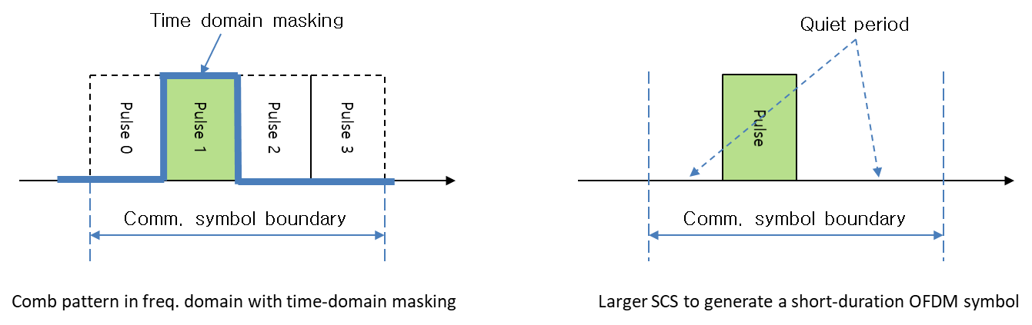
Figure 8. Short-duration pulse generations and configurations within an OFDM symbol duration
Proposal 13. If a pulse waveform is agreed to be further studied for sensing, RAN1 studies frame structure support for short-duration pulse transmission and associated quiet period.

    - Frame structure considerations for multiplexing of sensing and communication
This section discusses multiplexing of sensing and communication signals within the frame structure for 6G ISAC, focusing on how different multiplexing options can be realized under specific timing alignment conditions. Building on the multiplexing dimensions introduced in Chapter 2.2.1 and the CP and SCS considerations discussed in Chapter 2.2.2 and Chapter 2.2.3, this section identifies key physical-layer aspects that require further RAN1 study.
When TDM between sensing and communication is adopted, sensing and communication signals are allocated to different time resources within a common frame structure, such as different OFDM symbols, mini‑slots, or slots. Even though these resources are non‑overlapping in time, the relative timing relationship between sensing and communication signals needs to be clearly defined to ensure proper coexistence. From a frame structure and physical‑layer perspective, this includes how sensing symbols are positioned with respect to communication symbols and whether timing alignment is required at the OFDM symbol boundary or at a higher‑level boundary, such as the slot boundary. These timing alignment considerations directly impact the ability to reuse communication‑oriented synchronization procedures for sensing, as well as receiver processing complexity and robustness.
Proposal 14. If TDM between sensing and communication is agreed, RAN1 needs to study how sensing signal can be multiplexed with the communication signal, under a certain timing alignment condition.
As discussed in Chapter 2.2.2, CP extension may be considered for sensing in order to accommodate long‑delay sensing echoes that exceed the CP length assumed in communication‑oriented design. If such an approach is adopted, sensing and communication OFDM symbols may employ different CP lengths while sharing a common frame structure. From a frame structure and physical‑layer perspective, this introduces a scenario in which heterogeneous OFDM symbol formats coexist within a unified timing framework, raising design considerations related to symbol boundary maintenance, receiver FFT window positioning, and the impact of CP length mismatch on adjacent symbols. Proper handling of these aspects is essential to ensure robust coexistence of sensing and communication signals and to prevent unintended interference or degradation in either function.
Proposal 15. If CP extension is agreed for sensing, RAN1 needs to study how to multiplex OFDM symbols of different CP lengths between sensing and communication, under a certain timing alignment condition.
As discussed in Chapter 2.2.3, supporting a larger SCS for sensing may be beneficial, particularly when pulse‑based sensing is considered, as this introduces a mixed‑numerology scenario within the same frame structure. From a frame structure and physical‑layer perspective, coexistence of sensing and communication signals with different SCS values requires careful consideration of how OFDM symbols with different durations are multiplexed in time, how symbol and slot boundaries are preserved, and how potential inter‑numerology interference is managed. These aspects directly impact synchronization reuse, receiver processing robustness, and overall frame structure design, and therefore represent key considerations for enabling unified ISAC operation when multiple numerologies are supported.
Proposal 16. If a larger SCS is agreed for sensing, RAN1 needs to study how to multiplex OFDM symbols of different SCS between sensing and communication, under a certain timing alignment condition.
In addition to OFDM‑based sensing, new waveforms such as FMCW may be considered for sensing, noting that such waveforms differ fundamentally from OFDM in their time‑domain structure and signal generation principles. From a frame structure and physical‑layer perspective, supporting a non‑OFDM waveform for sensing while maintaining OFDM‑based communication introduces additional design considerations related to waveform coexistence within a common frame. In particular, it becomes necessary to define how FMCW‑based sensing signals are placed relative to OFDM symbols in time, what level of timing alignment is required between the two waveform types, and whether guard intervals or dedicated regions within a frame are needed to avoid mutual interference. Beyond simple time separation, there are multiple possible multiplexing approaches between FMCW and OFDM signals. For example, communication OFDM signals may be modulated by an FMCW waveform, such that the sensing receiver first demodulates the FMCW component and subsequently processes the OFDM symbols, allowing exploitation of sensing capabilities that are difficult to achieve with a pure OFDM system, while noting that this approach may introduce challenges such as effective bandwidth expansion due to the FMCW modulation. Alternatively, time‑domain multiplexing between OFDM symbols and FMCW signals may be considered, where FMCW is transmitted during the CP length or over a portion of the OFDM symbol duration. In addition, sequence combinations across multiple FMCW transmissions can be used to convey auxiliary information, for example related to sensing entities or sensing configuration. These multiplexing options directly impact frame‑level design, synchronization, receiver processing, and coexistence behavior, and therefore need to be carefully studied if FMCW is agreed to be supported for sensing within ISAC.
Proposal 17. If a new waveform such as FMCW is agreed for sensing, RAN1 needs to study how to multiplex communication OFDM symbols with the new waveform, under a certain timing alignment condition.
Pulse‑based sensing waveforms, introduce additional constraints due to their short duration and time‑localized nature when coexisting with OFDM‑based communication signals. From a frame structure and physical‑layer perspective, multiplexing pulse‑based sensing with communication requires careful consideration of how pulses are positioned relative to OFDM symbols or slots, how timing alignment is defined, and how guard times are configured to avoid mutual interference. These aspects directly affect frame‑level multiplexing, synchronization reuse, and receiver processing, and are essential to ensure that pulse‑based sensing can be integrated into a unified ISAC frame structure without degrading communication performance.
Proposal 18. If a pulse waveform is agreed for sensing, RAN1 needs to study how to multiplex communication OFDM symbols with the pulse waveform, under a certain timing alignment condition.
  - Evaluation methods for waveform and frame structure
This section discusses evaluation methods for waveform and/or frame structure enhancements for 6G ISAC, based on the agreement in RAN1 #124-bis. In particular, theoretical waveform characteristics analysis, link-level simulation, and system-level simulation are considered in terms of their necessity, pros and cons, and relevant evaluation metrics.
    - Waveform characteristics analysis
For the evaluation of waveform and/or frame structure enhancements for 6G ISAC, theoretical waveform characteristics analysis can be used as an initial and useful evaluation method. Since candidate sensing waveforms or waveform enhancements may have different time-domain and frequency-domain signal properties, it is important to identify metrics that can capture the fundamental characteristics affecting sensing performance and integration with communication. In this regard, ambiguity-function-related characteristics and PAPR can be considered as evaluation aspects.
Ambiguity-function-related characteristics are relevant for evaluating sensing waveform properties. In CP-OFDM based sensing, the RE pattern in the frequency domain is directly related to the range-domain response. As discussed in Section 2.1.1, a uniformly spaced comb-type RE pattern may result in repeated peaks in the range-domain response, which can cause range ambiguity. A non-uniform RE pattern can reduce such periodic ambiguity structure, but it may introduce other trade-offs such as PAPR increase and processing complexity. Therefore, ambiguity-function-related metrics, such as main-lobe width, side-lobe behavior, peak-to-side-lobe ratio, integrated side-lobe ratio, and auto-/cross-correlation properties, are useful for comparing candidate waveform or RS designs in terms of resolution, ambiguity, false target behavior, and separability among different sensing signals.
PAPR is also an important metric because it affects the required power amplifier back-off and hence the effective transmit power available for sensing signal transmission. This is particularly relevant for sensing, since target-reflected signals may be weak and sensing performance can be sensitive to the received SNR. As discussed in Section 2.1.1, a non-uniform RE pattern in the frequency domain can mitigate range ambiguity, but it may also increase the PAPR of CP-OFDM based reference signal transmission. For example, the PAPR comparison in Table 2 shows that the non-uniform RE pattern has higher PAPR than the uniform 4-comb RE pattern under the considered assumptions. Therefore, waveform or RS pattern enhancements for sensing need to be evaluated from both the ambiguity-function-related perspective and the PAPR perspective.
However, waveform characteristics analysis alone may not be sufficient to fully evaluate the actual sensing performance and the impact on communication. For example, ambiguity-function-related metrics and PAPR can provide useful insights into the intrinsic waveform properties, but actual performance may also depend on channel conditions, target and background scattering, interference, receiver processing assumptions, synchronization errors, hardware impairments, and multiplexing/coexistence with communication signals. Therefore, theoretical waveform characteristics analysis can be used to evaluate waveform and/or frame structure enhancements for 6G ISAC, while it may need to be complemented, when needed, by link-level simulation to quantify sensing performance and communication impact under relevant ISAC scenarios.
Proposal 19. RAN1 evaluates waveform and/or frame structure enhancements for 6G ISAC based on theoretical waveform characteristics analysis, including ambiguity-function-related characteristics and PAPR.
    - Link-level simulation (LLS) for evaluations
In addition to theoretical waveform characteristics analysis, LLS can be used for evaluating waveform and/or frame structure enhancements for 6G ISAC. System-level simulation is suitable for evaluating network-level ISAC operation, including multiple sensing entities, multiple targets, inter-node interference, and sensing cooperation. However, such system-level evaluation includes many deployment-dependent and environment-dependent variables, which may make it difficult to isolate the impact of the waveform or frame structure itself. In contrast, LLS can focus on the received signal and receiver processing at a single sensing entity under controlled channel and impairment assumptions. Therefore, LLS is suitable for comparing waveform and/or frame structure enhancements, including waveform comparison, detection performance versus SNR or target distance, and the impact of TX/RX/channel impairments on sensing processing.
Proposal 20. RAN1 evaluates waveform and/or frame structure enhancements for 6G ISAC based on link-level simulation.
For LLS -based evaluation, an ISAC LLS channel model needs to be considered. In Rel-19 ISAC channel modelling SI, ISAC LLS channel modelling was discussed as shown below.
FL1] Question 8.1-1
Which option is preferred to model link-level channel for ISAC?
- Option 1: Based on existing CDL channel model,
  - Alt 1: add one or more clusters representing target(s)
  - Alt 2: Update the parameters of one or more cluster to represent target(s)
- Option 2: Reducing the system level channel model for ISAC to single Tx and single Rx
- Option 3: The Tx-target link and target-Rx link are modelled by separate CDL channels, concatenation is then performed to get the target channel; the background channel is modelled by another CDL channel.
- Option 4: Not supported
Though there were no consensus to develop LLS channel modelling that time, we need to think of possibility for introduction of ISAC LLS channel modelling for e.g., waveform evaluation/selection. Among the options above, our proposal is close to Option 3, which has same concatenated structure as the target channel in SLS channel model. On the other hand, we’re also open to Option 2. We can further discuss what exact model of the existing CDL model can be used for sensing LLS.
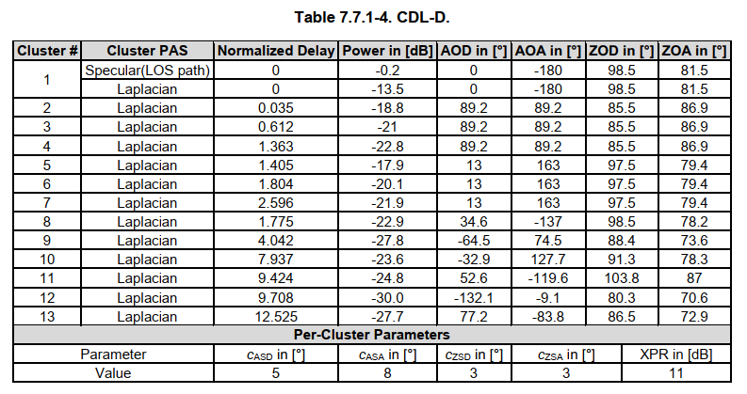 Noise: AWGN represents both Background channel and thermal leakage / compensation noise. Once baseline (average) power level for background and leakage is selected (Noise is fixed), SNR can be recalculated into the target distance (Signal power scaled with pathloss)
Proposal 21 If ISAC LLS channel modelling is agreed, ISAC LLS channel can be modelled with the baseline CDL-D model, with the following changes:
  - Define random or fixed target position with respect to the sensing TX and RX
  - Select the LOS AoA/AoD in accordance with target position, modify cluster angles in Table 7.7.1-4 accordingly
  - Generate normalized CIR for each antenna pair following Section 7.7.1 of [7]
  - If relevant, add propagation delay corresponding to the sensing TX-ST, ST-sensing RX distances.

3. Conclusions
In this contribution, the issues related to the waveform and frame structure for 6G ISAC were discussed. The following observations and proposals were made as conclusions.
Observation 1. Non-uniform RE patterns in the frequency domain may increase the PAPR of CP-OFDM based reference signal transmission.
Observation 2. FMCW is a conventional waveform widely used in the radar field, with favorable transmit waveform characteristics including low-PAPR properties.
Observation 3. The sensing performance such as range accuracy, Doppler accuracy, and ambiguity behavior is observed to be very similar between OFDM‑based and FMCW‑based sensing when comparable bandwidth and signal duration are used.
Observation 4. OFDM‑based sensing performance may be degraded under strong co‑channel interference.
Observation 5. FMCW‑based sensing performance can be less sensitive to the conditions under which OFDM‑based sensing performance is degraded, providing more robust sensing behavior in interference‑limited environments.
Observation 6. For FMCW-based sensing, chirp signals with different sweep directions, e.g., up-chirp and down-chirp, can be beneficial for mitigating range-Doppler coupling.
Observation 7. For sensing coverage enhancement in both mono-static sensing and bi-static sensing, pulse waveform can be beneficial.
Observation 8. For pulse waveform-based sensing, supporting different pulse widths can provide flexibility to balance self-interference avoidance, range resolution, and detection sensitivity.
Observation 9. The sensing signal scattered by an object can propagate beyond OFDM CP length, which may cause inter-symbol interference between adjacent symbols.
Observation 10. In OFDM‑based sensing, the SCS affects sensing coverage in the velocity domain by determining the maximum tolerable target velocity under Doppler‑induced inter‑carrier interference.
Observation 11. As one of the pulse waveform generation methods, a larger SCS can be used to shorten OFDM symbol duration.

Proposal 1. RAN1 studies low-PAPR sequence enhancements for non-uniform RS RE patterns in the frequency domain.
Proposal 2. FMCW can be studied as a candidate waveform in the ISAC study.
Proposal 3. If FMCW-based waveform is agreed to be further studied, RAN1 studies chirp signal variations and corresponding generation methods, taking into account sensing performance and implementation-related aspects.
Proposal 4. RAN1 studies a pulse waveform as a candidate waveform for sensing.
Proposal 5. If a pulse waveform is agreed to be further studied for sensing, RAN1 studies supported pulse width configuration(s), including whether a single pulse width value or a set of pulse width values is needed.
Proposal 6. If pulse waveform is agreed to be used for sensing, RAN1 studies the exact shape of pulse waveform.
  - Rectangular pulse without modulation
  - Rectangular pulse with modulation
  - A waveform (e.g., OFDM/FMCW) of pulse width
Proposal 7. If rectangular pulse with modulation is agreed, RAN1 needs to study the exact modulation method.
Proposal 8. If pulse waveform is agreed to be used for sensing, RAN1 needs to study the generation method of pulse waveform.
Proposal 9. RAN1 studies the necessity and potential benefits of specifying waveforms for TRP monostatic sensing, TRP-TRP bistatic sensing, and UE monostatic sensing.
Proposal 10. RAN1 studies how to handle the interference from the sensing signal that propagates beyond the OFDM CP length.
  - Alt 1: CP length extension
  - Alt 2: Silent gap before and/or after a sensing signal
  - Alt 3: Effective CP extension by symbol repetition
Proposal 11. If a pulse waveform is agreed to be used for sensing, RAN1 studies whether to support a larger SCS for sensing.
Proposal 12. If a pulse waveform is agreed to be used for sensing, SCS for sensing can be determined according to the required pulse waveform width.
Proposal 13. If a pulse waveform is agreed to be further studied for sensing, RAN1 studies frame structure support for short-duration pulse transmission and associated quiet period.
Proposal 14. If TDM between sensing and communication is agreed, RAN1 needs to study how sensing signal can be multiplexed with the communication signal, under a certain timing alignment condition.
Proposal 15. If CP extension is agreed for sensing, RAN1 needs to study how to multiplex OFDM symbols of different CP lengths between sensing and communication, under a certain timing alignment condition.
Proposal 16. If a larger SCS is agreed for sensing, RAN1 needs to study how to multiplex OFDM symbols of different SCS between sensing and communication, under a certain timing alignment condition.
Proposal 17. If a new waveform such as FMCW is agreed for sensing, RAN1 needs to study how to multiplex communication OFDM symbols with the new waveform, under a certain timing alignment condition.
Proposal 18. If a pulse waveform is agreed for sensing, RAN1 needs to study how to multiplex communication OFDM symbols with the pulse waveform, under a certain timing alignment condition.
Proposal 19. RAN1 evaluates waveform and/or frame structure enhancements for 6G ISAC based on theoretical waveform characteristics analysis, including ambiguity-function-related characteristics and PAPR.
Proposal 20. RAN1 evaluates waveform and/or frame structure enhancements for 6G ISAC based on link-level simulation.
Proposal 21 If ISAC LLS channel modelling is agreed, ISAC LLS channel can be modelled with the baseline CDL-D model, with the following changes:
  - Define random or fixed target position with respect to the sensing TX and RX
  - Select the LOS AoA/AoD in accordance with target position, modify cluster angles in Table 7.7.1-4 accordingly
  - Generate normalized CIR for each antenna pair following Section 7.7.1 of [7]
  - If relevant, add propagation delay corresponding to the sensing TX-ST, ST-sensing RX distances.

4. References
- R1-2602985, Summary on Waveform and frame structure for 6G ISAC, LG Electronics (Moderator), RAN1 #124-bis, St Julian’s, Malta, April 13-17, 2026.
- RP-251881, New SID: Study on 6G Radio, NTT DOCOMO (Moderator), RAN#108, Prague, Czech Republic, June 9-13, 2025.
- R1-2601945, Waveform and signal for 6GR ISAC, Huawei, HiSilicon, RAN1 #124-bis, St Julian’s, Malta, April 13-17, 2026.
- R1-2602205, Discussion on waveform and frame structure, Samsung, RAN1 #124-bis, St Julian’s, Malta, April 13-17, 2026.
- R1-2603031, Considerations on Integration with Communication, Qualcomm, RAN1 #124-bis, St Julian’s, Malta, April 13-17, 2026.
- Carvajal, Gisela K., et al. "Comparison of automotive FMCW and OFDM radar under interference." 2020 IEEE Radar Conference (RadarConf20). IEEE, 2020.
- 3GPP TR 38.901 V19.0.0 (2025-06), “Study on channel model for frequencies from 0.5 to 100 GHz (Release 19)”

